KENDRIYA VIDYALAYA No.2, BOLANGIR

# SUMMATIVE ASSESSMENT- II SESSION: 2013-14

CLASS: III SEC___ TIME: 2 ½ Hrs

SUBJECT: EVS MAX.M: 60

NAME: ________________________________________________ Roll No.:______

DATE: ____-03-2014

Invigilator’s Sign______ Examiner’s Sign. _________

|  |  |  |  |
| --- | --- | --- | --- |
| OBSERVATION & REPORTING | IDENTIFICATION & CLASSIFICATION | DISCOVERY OF FACTS | OVERALL |
|  |  |  |  |

# OBSERVATION AND REPORTING

Q.1 Observe the following pictures and write the name of the following ?

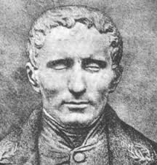 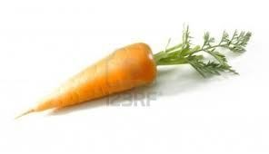 

a) ____________________ b)____________________ c) _________________

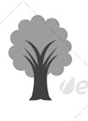

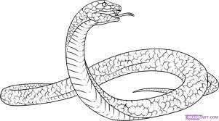

d) _______________ e) __________ f) ____________ g)_____________

Q.2 Observe the given picture and answer the following questions.

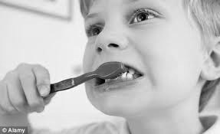 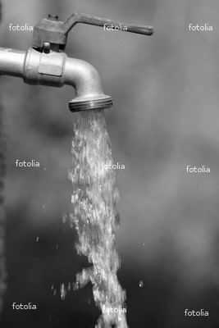

1. Write two ways of saving water.

___________________________________________________________________ ___________________________________________________________________

___________________________________________________________________

___________________________________________________________________

1. Write four uses of water.

___________________________________________________________________

___________________________________________________________________ ___________________________________________________________________

___________________________________________________________________

1. Answer the question given below.

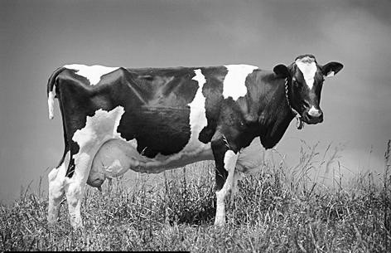

* + 1. Name of animal ___________________________
    2. Why do we keep it?

___________________________________________________________________

___________________________________________________________________

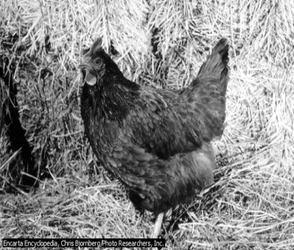

1. (i) Name of bird __________________

(ii) Why do we keep it ?

___________________________________________________________________ ___________________________________________________________________

* 1. Look at the pictures and match.

Hut

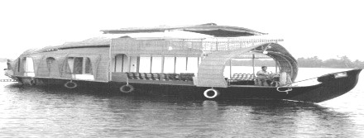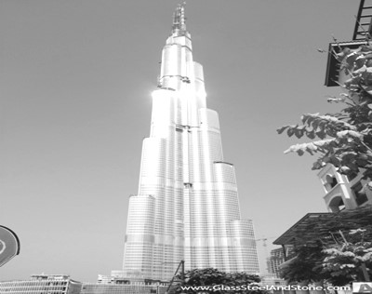

Igloo

Tent

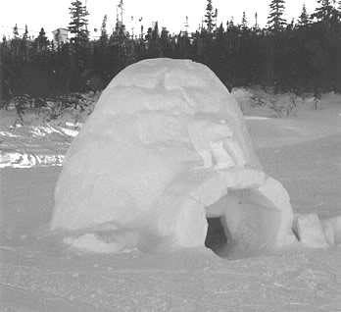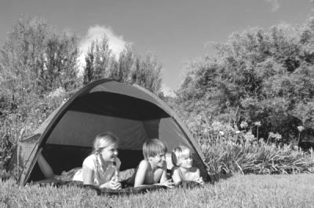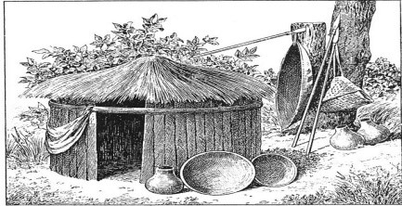

House Boat

Multi- storied Building

IDENTIFICATON AND CLASSIFICATION

* 1. Encircle the odd one.
     1. Lemon Orange Garlic Mausambi
     2. Potato Turnip Corn Onion
     3. Honey Meat Egg Banana
     4. Cabbage Turmeric Ajain Chilli
     5. Pea Gram Cauliflower Rajma
  2. Write the name of any two of the following items and complete the table.

|  |  |  |
| --- | --- | --- |
| Spices |  |  |
| Seeds |  |  |
| Sources of water |  |  |
| Mathematical symbols |  |  |
| Clay pots |  |  |

* 1. Who eats what? Match by drawing lines.

Snake

Lizard

Human being

Sparrow

Goat

Mosquito

Chapati

Rat

Grass

Insect

DISCOVERY OF FACTS Q.7 i) What does PIN stand for ?

_________________________________________________________________

ii) Write the names of any one Indoor Game.

_________________________________________________________________ iii) Which medicine do you take from plants when you

Get hurt _________________ iv) Who first thought of Braille script ?

_________________________________________________________________

v) _____________ is called as the ship of the desert.

Q.8 (i) Answer the questions given below.

* + 1. Name four medicinal plants.

_____________ _______________ _____________ _______________

* + 1. What things does a potter need to make a pot? [Any 4]

_________________________________________________________________

* + 1. Who brings letters to your house?

_________________________________________________________________

* + 1. Write two indoor games and two outdoor games.

 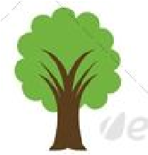

|  |  |
| --- | --- |
| 1. | 1. |
| 2. | 2. |

* + 1. Draw your family tree.

Q.9 Write a Slogan on “Saving Water” and decorate it.

_________________________________________________________________

_________________________________________________________________

_________________________________________________________________

# KENDRIYA VIDYALAYA No.2, BOLANGIR

SUMMATIVE ASSESSMENT- II SESSION: 2013-14

CLASS: IV SEC___ TIME: 2 ½ Hrs

SUBJECT: EVS MAX.M: 60

NAME: ________________________________________________ Roll No.:______

DATE: ____-03-2014

Invigilator’s Sign______ Examiner’s Sign. _________

|  |  |  |  |
| --- | --- | --- | --- |
| OBSERVATION & REPORTING | IDENTIFICATION & CLASSIFICATION | DISCOVERY OF FACTS | OVERALL |
|  |  |  |  |

## OBSERVATION AND REPORTING

Q.1 Observe the picture and answer

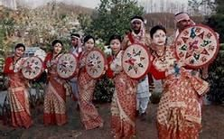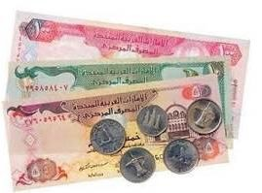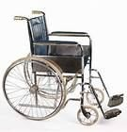

1. Name the folk dance and the state related with

Ans:-______________________________

1. Name the currency and the country where is it used?

Ans:-______________________________

1. Name the picture ? Who uses it ?

Ans:-______________________________

1. Name the spice used to heal wounds .

Ans:_______________,____________________

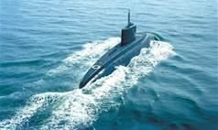

1. Name the means of transportation.

Ans:_____________________

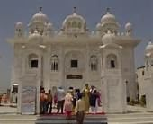

1. Name the place of worship

Ans:_____________________

Q.2 Answer the following questions –

a) What are sand dunes? Where are they found?

Ans: ___________________________________________________________

____________________________________________________________

____________________________________________________________ b) Write two uses of water.

Ans:- i) ______________ ii) _______________

1. What are the responsibilities of a naval doctor on a ship? (Any two)

Ans: ___________________________________________________________

____________________________________________________________

____________________________________________________________

1. What is an Oasis ? Where is it found?

Ans: ___________________________________________________________

____________________________________________________________

____________________________________________________________

* 1. Write and explain the steps involved in weaving a pochampalli saree in proper order .

Ans: ___________________________________________________________

____________________________________________________________ ____________________________________________________________

____________________________________________________________

____________________________________________________________ ____________________________________________________________

____________________________________________________________

____________________________________________________________

____________________________________________________________ IDENTIFICATION AND CLASSIFICATION

* 1. Fill in the blanks –

1. __________is the most common fruit of desert .
2. Wahida prism is a doctor in Indian__________.
3. A __________has many number of needles of different sizes.
4. ------------- is the main occupation of the people in India.

v) The rearing of silkworm is known as ___________.

Q.5 a) Write four different purpose for which the birds use their feet and claws?

Ans:- 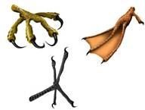

________________________________________________________________________ ________________________________________________________________________

________________________________________________________________________

________________________________________________________________________

________________________________________________________________________ b) Match it

A B

A person who can”t speak blind

A person who can”t hear dumb

A person who can”t walk lame

A person who can”t see deaf

1. Write two differences between tap roots and fibrous roots .

Ans:-

|  |  |
| --- | --- |
| Tap roots | Fibrous roots |
|  |  |
|  |  |

1. Write the full form of
   * 1. O R S = __________________________________________

* + 1. L P G = __________________________________________.

1. What do you mean by conservation of water ? Suggest two ways for it.

Ans: ___________________________________________________________

___________________________________________________________ ___________________________________________________________

___________________________________________________________ ___________________________________________________________

Q.6 Write five differences between KERALA and ABUDHABI on the basis of their

(Landform, Currency, Languages, Clothes, Important features) Ans.

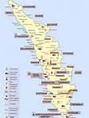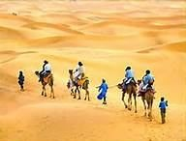

_____________________ _______________________

_____________________ _______________________ _____________________ _______________________

_____________________ _______________________ _____________________ _______________________ _____________________ _______________________

_____________________ _______________________ _____________________ _______________________DISCOVERING THE FACTs

Q.7 Write True or False.

i) It is very cold in deserts during day time . ( ) ii) There is plenty of petroleum deposits in Abu dhabi . ( ) iii) Bridges are built over mountains. ( )

iii) Village people face a lot of problem for drinking water . ( ) iv) Girls and boys should be treated differently. ( )

Q.8 Answer the questions –

1. Why do people wear loose cotton clothes in Abu dhabi?

Ans: ___________________________________________________________

___________________________________________________________

___________________________________________________________

___________________________________________________________

1. What are spices ? Why are spices added to food ?

Ans: ___________________________________________________________

___________________________________________________________ ___________________________________________________________ ___________________________________________________________ c) Name two natural fibres.

Ans- i) ____________________ ii)__________________.

1. Many weavers are giving up this craft which their family has been doing for years. Why?

Ans ____________________________________________________________

________________________________________________________________

1. What was chuskit’s dream ?Why could’t she go to school ?

Ans: ___________________________________________________________

___________________________________________________________

___________________________________________________________

Q.9 On the outline map of India mark and name the following -

Shade and name

i) The cold desert of India ii) The state known as Land of spices

* + 1. The state known for pochampalli saree.
    2. Mark and name two neighbouring countries of India

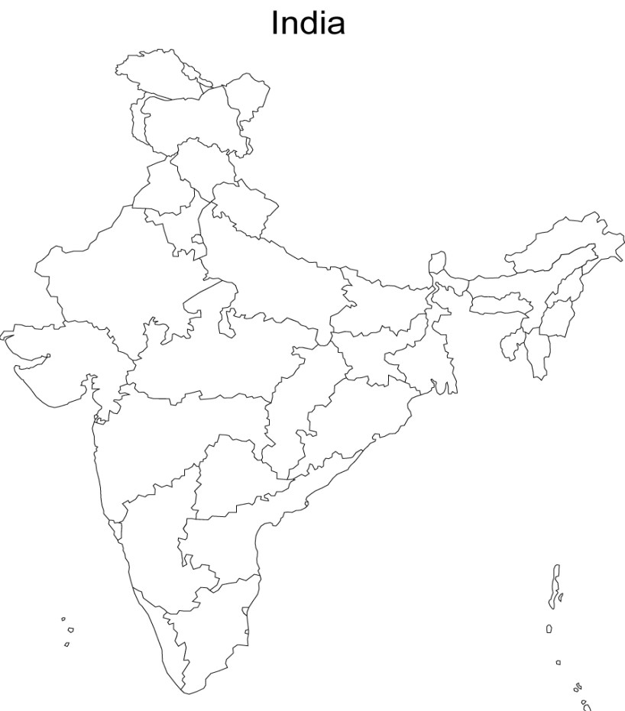

KENDRIYA VIDYALAYA No.2, BOLANGIR

## SUMMATIVE ASSESSMENT- II SESSION: 2013-14

CLASS: V SEC___ TIME: 2 ½ Hrs

SUBJECT: EVS MAX.M: 60

NAME: ________________________________________________ Roll No.:______

DATE: ____-03-2014

Invigilator’s Sign______ Examiner’s Sign. _________

|  |  |  |  |
| --- | --- | --- | --- |
| OBSERVATION & REPORTING | IDENTIFICATION & CLASSIFICATION | DISCOVERY OF FACTS | OVERALL |
|  |  |  |  |

## OBSERVATION

Q1. Observe the following pictures and answer each question

|  |  |
| --- | --- |
| a) What activity is shown in this picture?    ____________________________ |  |
| b) Write the name of the person.    __________________________ |  |
| c) What is shown in this picture?    _____________________________ |  |
| d) Who is the girl in this picture?    _______________________ |  |
| e) Who is this woman?    _________________________ |  |
| f) Many families in Srinagar live in it. Write its name.    _______________________ |  |
| g) Write the name of the natural disaster.    ________________________ | Ahmedabad, 26-January, 2001 |

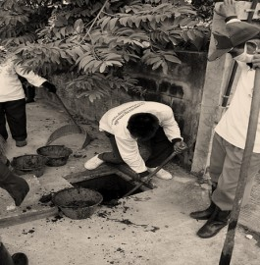

1. 1) What the man is doing?

___________________________________

2) What kind of difficulties do these people face in doing their work?

_____________________________________________________________________ _____________________________________________________________________

__

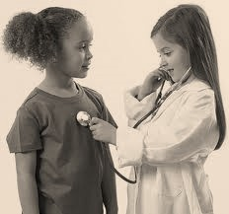

1. 1) Name the instrument used in this picture?

____________________________________

2) What is the use of this instrument?

__________________________________________________________________

1. 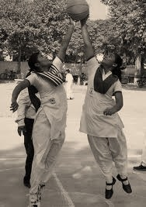1) Name the game shown in this picture?

______________________________________

2) What is the full form of N.B.A.

_______________________________________

_______________________________________

1. What is this man doing and why?

_______ _____________________________________

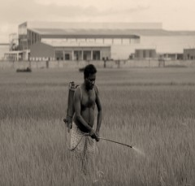

_____________________________________________ _____________________________________________

1. Arrange the following pictures in a proper sequence. Explain each step of farming in your own sentence.

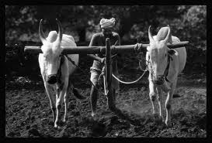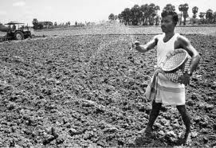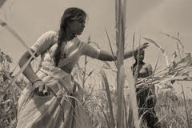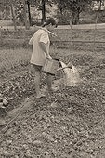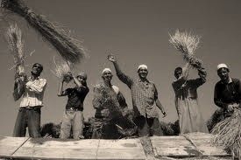

_____________________________________________________________________

_____________________________________________________________________

_____________________________________________________________________ _____________________________________________________________________ ____

_____________________________________________________________________

_

_____________________________________________________________________

_

_____________________________________________________________________

_

## IDENTIFICATION AND CLASSIFICATION

Q.2 Fill in the blanks

1. _____________ is a sweet rotis made from jiggery and gram.
2. Polio is caused by a __________
3. Torang means _____________ in Kuduk language.
4. In earlier times farmers used ___________ leaves to protect seeds

from insects.

1. ______________ is the harvest festival of Assam. Q.3 Write the name of two products obtained from sugarcane.
   * 1. ________________
     2. ________________
   1. Classify the following agricultural tools or machine into respective group.

Power tiller, Plough, Sickle, Tractor

|  |  |
| --- | --- |
| Traditional | Modern |
|  |  |

* 1. Classify the following sources of energy into respective group. Solar energy, Petrol, Coal, Gobar gas

|  |  |
| --- | --- |
| Renewable | Non renewable energy |
|  |  |

* 1. Write the national game of the following countries.

|  |  |
| --- | --- |
| COUNTRY | NATIONAL GAME |
| India |  |
| England |  |

* 1. What is Jhoom farming?

________________________________________________________________________

________________________________________________________________________ ________________________________________________________________________

________________________________________________________________________

________________________________________________________________________

* 1. a) What is an earthquake? What should we do when an earthquake occurs?

________________________________________________________________________

________________________________________________________________________

________________________________________________________________________ ________________________________________________________________________

________________________________________________________________________

________________________________________________________________________ ________________________________________________________________________

________________________________________________________________________

## DISCOVERY OF FACTS

Q.9 Match the column.

A B

|  |  |
| --- | --- |
| a. Gregor Mendel | Ladakh |
| b. Lottery for farming | Petroleum |
| c. Donga | Mizoram |
| d. crude oil | Dal lake |
| e. cold desert | Law of hereditary |

Q.10 What happens to your chest when you breathe in and breathe out?

______________________________________________________________________ ______________________________________________________________________

______________________________________________________________________

______________________________________________________________________

Q.11 Give reasons.

Why earthworm is called a farmer’s friend?

________________________________________________________________________

________________________________________________________________________ ________________________________________________________________________ ________________________________________________________________________ Q.12 What is Right to Forest Act 2007?

______________________________________________________________________ ______________________________________________________________________

______________________________________________________________________ ______________________________________________________________________ ____

Q.13 What is cold desert?

______________________________________________________________________ ______________________________________________________________________ ______________________________________________________________________ ___

Q.14 How coal is formed?

________________________________________________________________________

________________________________________________________________________

________________________________________________________________________ ________________________________________________________________________

Q.15 Observe the India map and answer the following questions.

1. Write the name of two states which have very thick forest

_______________________ ___________________________

1. For someone in Madhya Pradesh, in which direction would the country’s thickest forests be?

______________________________________________________

1. Which are the states which have the sea on one side? Write any two.

____________________________ _________________________

1. Write the capital of the following states

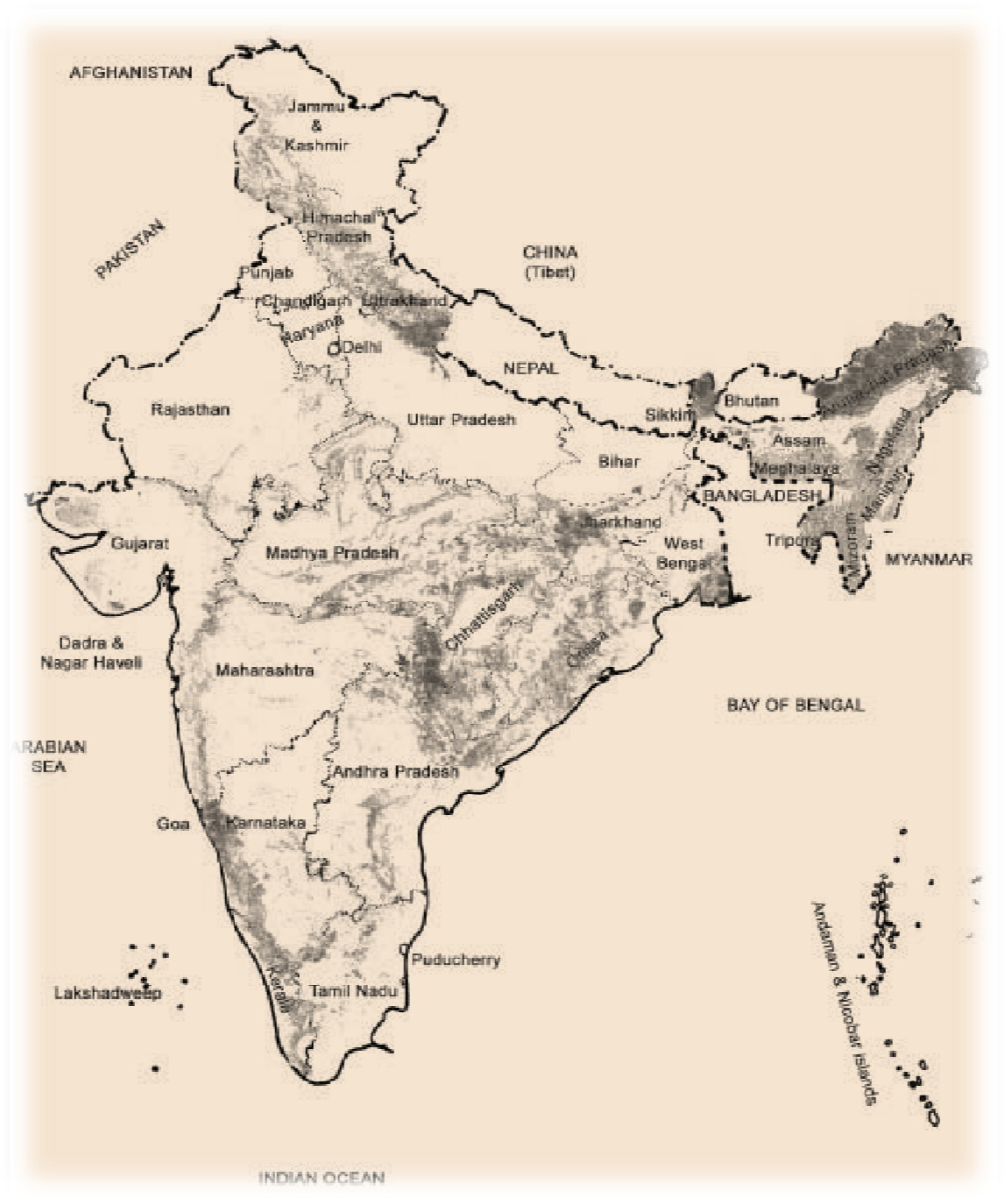



|  |  |
| --- | --- |
| STATES | CAPITALS |
| Jharkhand |  |
| Chhattisgarh |  |
| Tamil Nadu |  |
| Odisha |  |
| Maharashtra |  |